Assignment 1:

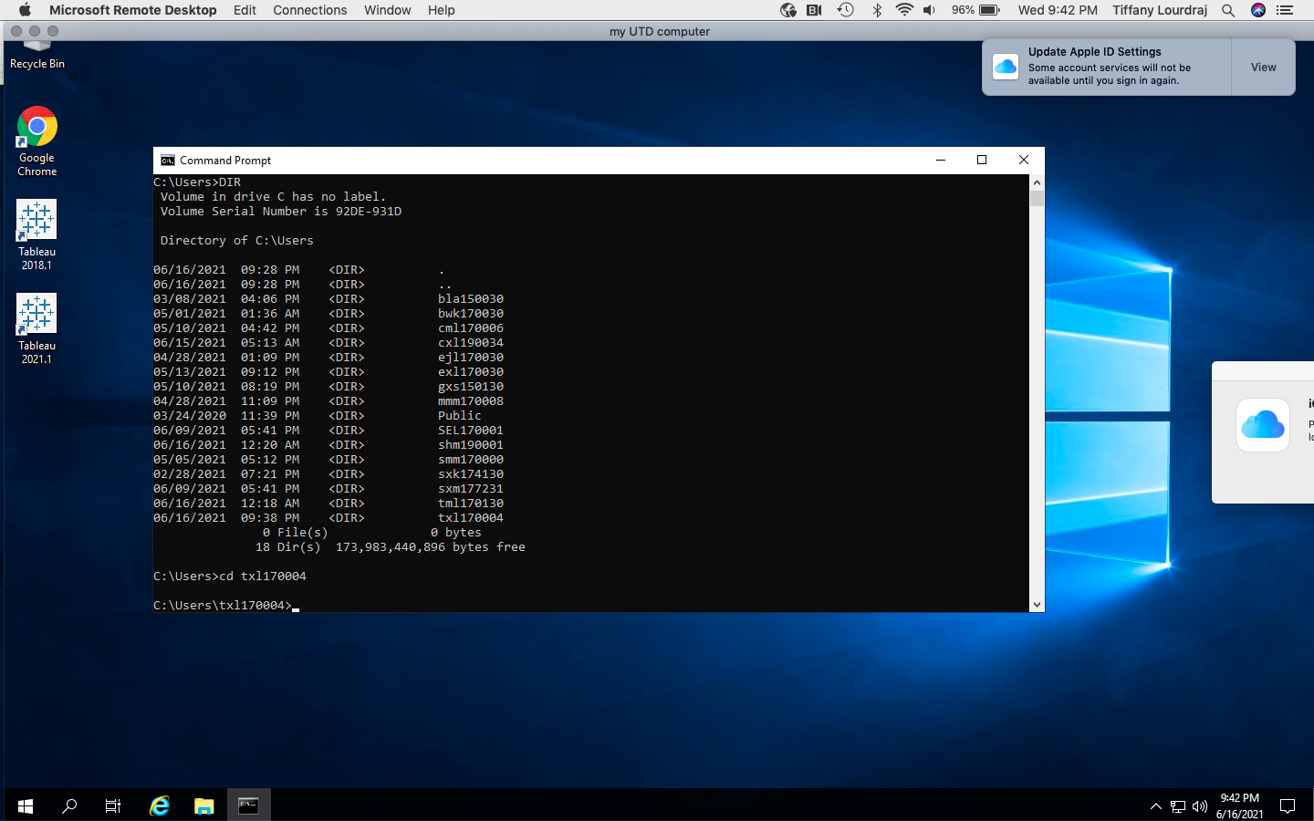

Assignment 2:

1.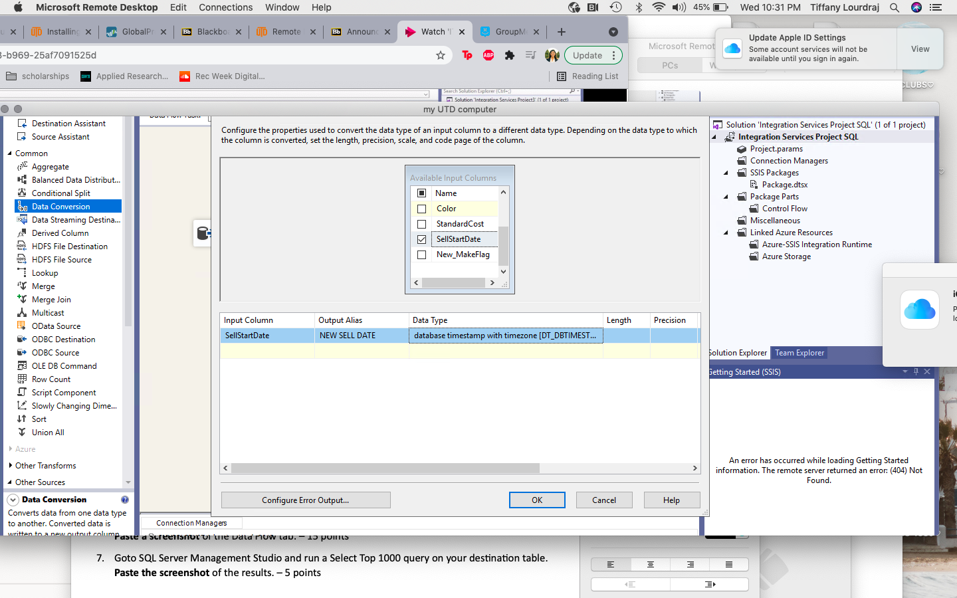

2. 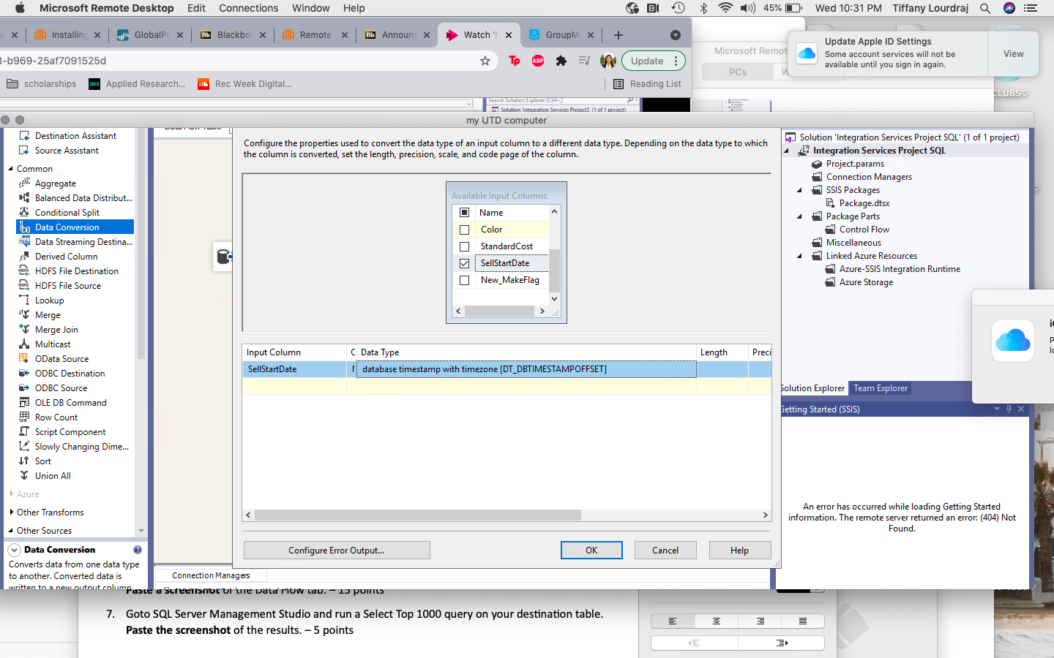

3. 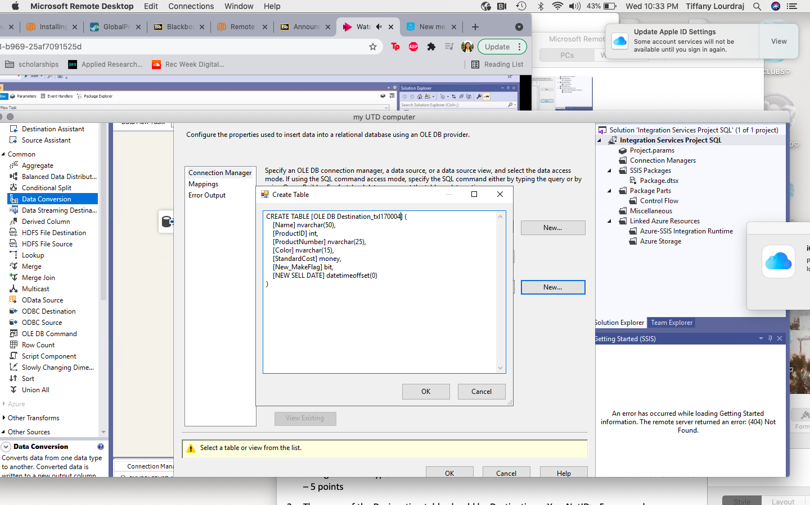

4. 4. 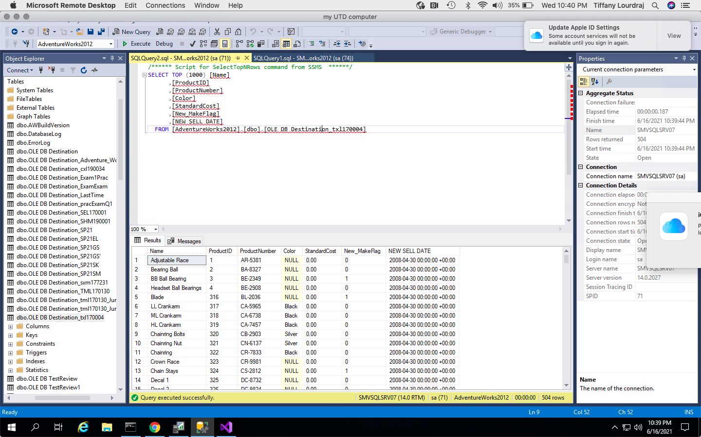\

5. 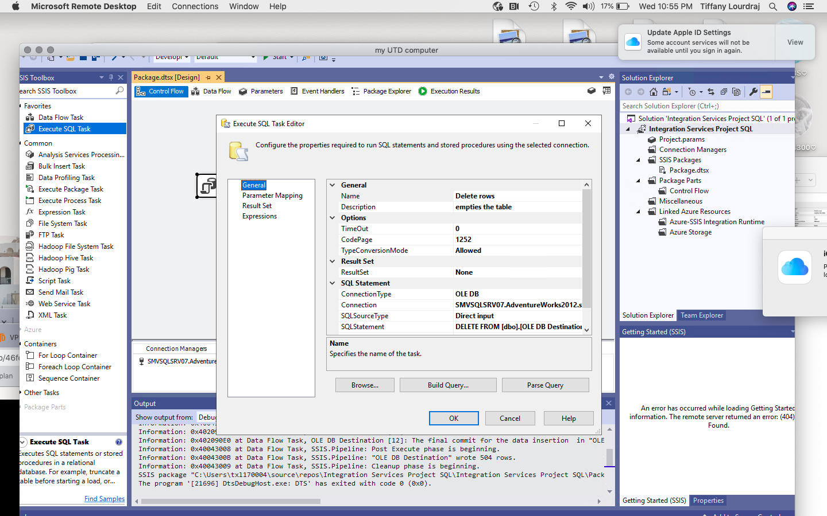

6. 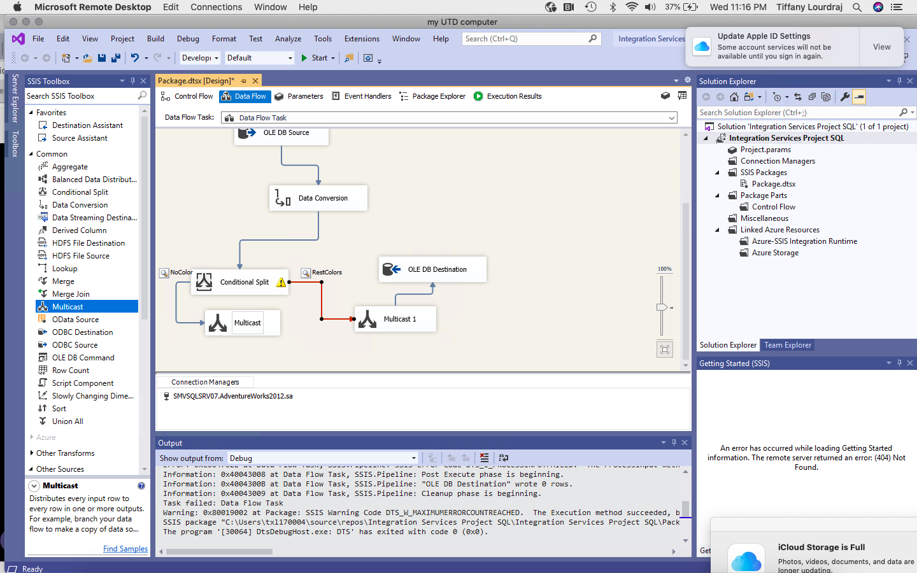

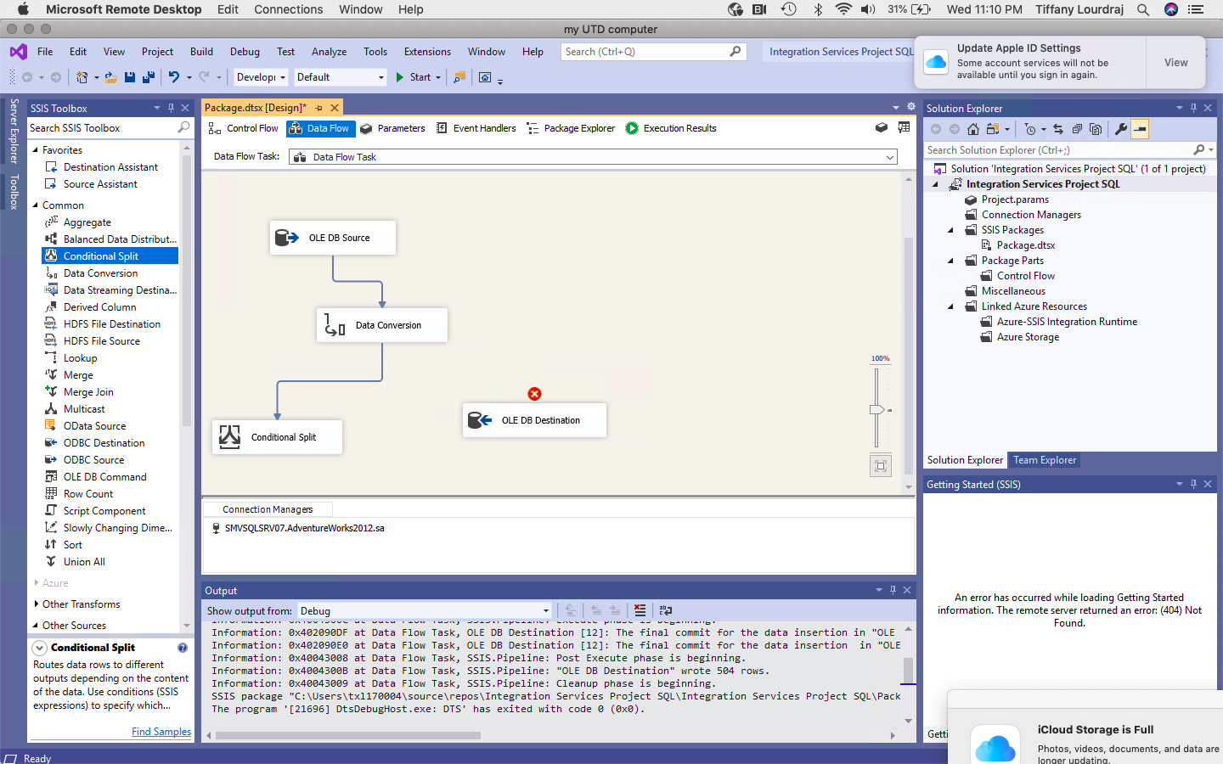

7. 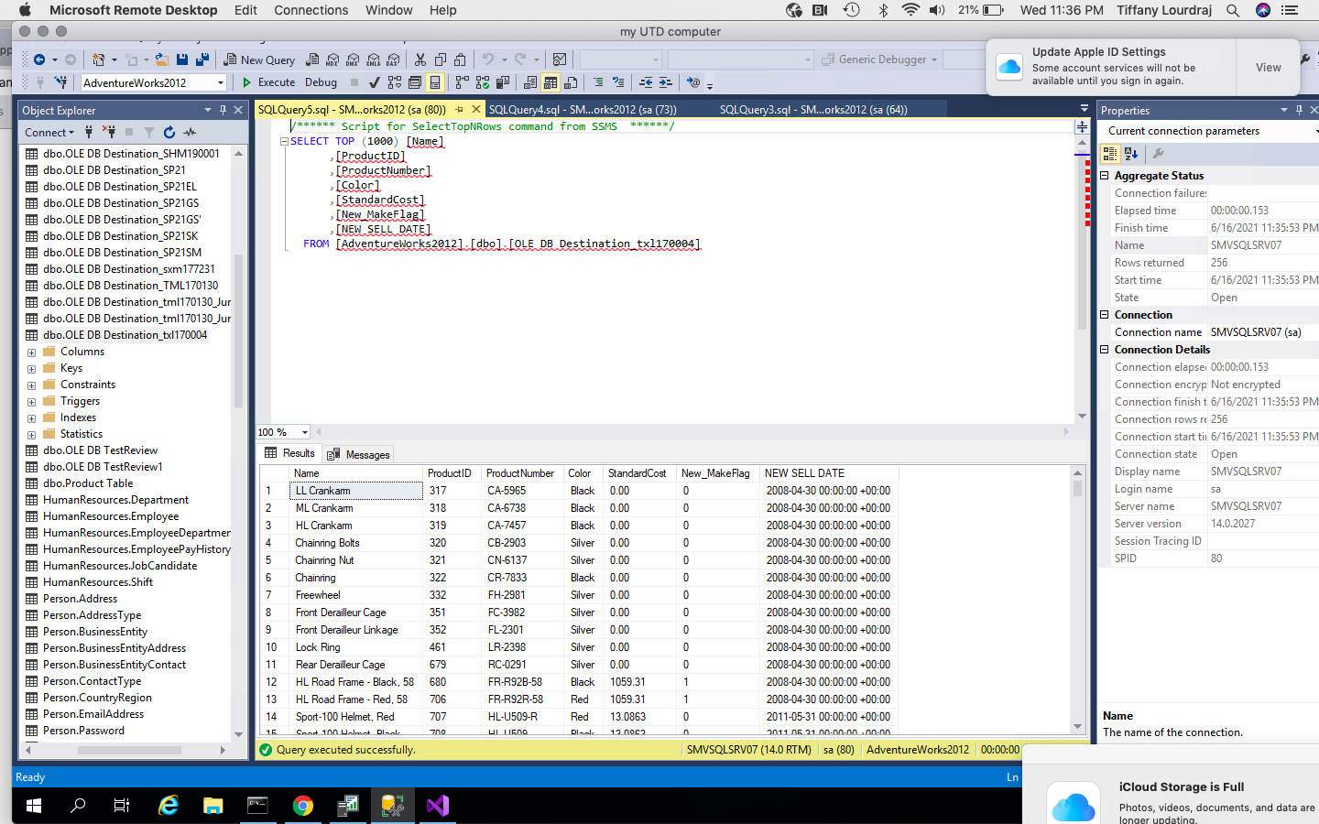

**Assignment 3**

**SSIS/SSAS/Tableau**

*ITSS* *4351:* *Foundations* *of* *Business* *Intelligence*

**Total – 50 points**

**NOTE:**

1. **You will get ONLY ONE chance to submit your assignment. No resubmissions allowed**
2. **Any request to clear an incorrect submission would not be entertained**
3. **Paste all the screenshots with the respective sub questions. Do not simply paste them at the bottom of the document. Everything has to be submitted as part of this document ONLY.**
4. **The screenshot should show the entire screen. Do not crop the screenshot. I should be able to see everything including the taskbar.**

# Part 1: ETL-Tableau: 30 points

Adventure Works Inc is one of the largest suppliers of the motor parts in North America. As part of their IT expansion initiative “Mission 2028”, they want to revamp their Legacy systems. This includes upgrading their databases from flat files to a RDBMS. The company also wants to aggressively follow up their reports by moving from excel charts to visualization tools like Tableau. The inventory team would like to conduct a pilot test as defined below.

1. The Inventory team wants to create a new table in the AdventureWorks2012 dataset, which is a subset of the Product table, that is used in the Production environment. The new table should have the ProductID, Name, ProductNumber and MakeFlag. There should be no duplicate columns. Also the field “MakeFlag” should be renamed to “NEW_MakeFlag”. **Paste a Screenshot – 5 points 6/7 at 26:00**

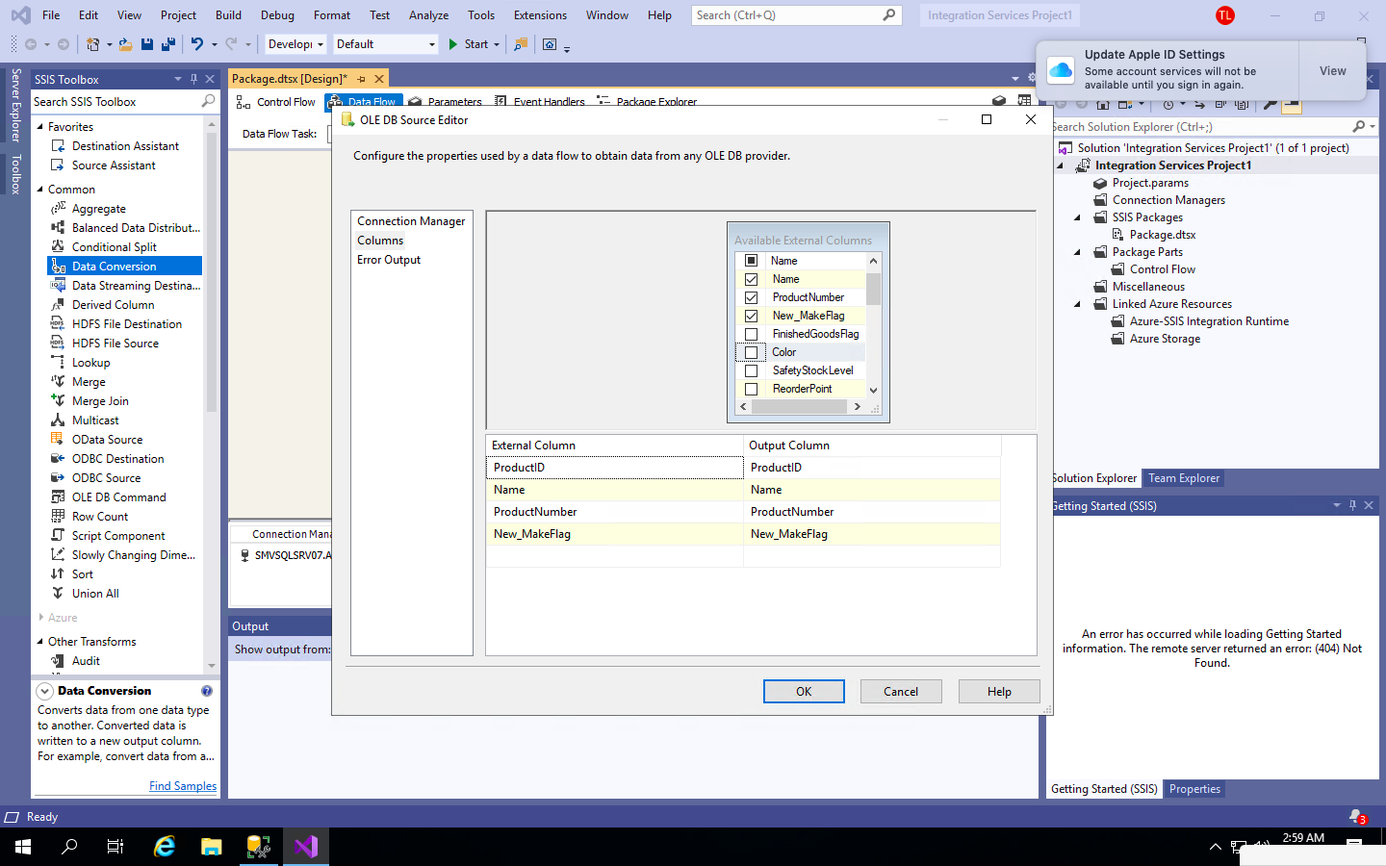

2. The team wants to make sure that no duplicates are inserted in this new custom table. Since the size of the table is small, they decided to go ahead and insert all the rows from the parent table, each time the SSIS package was executed. **Paste a Screenshot – 5 points**

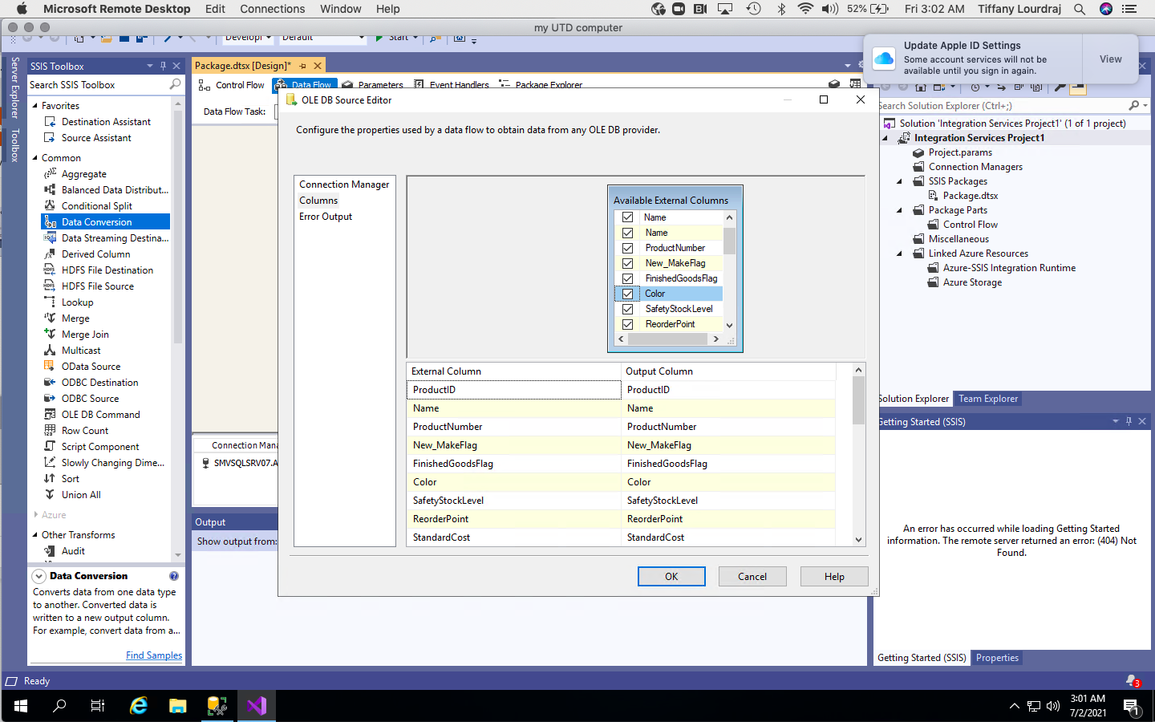

3. The resulting values from the new custom table needs to be projected on Tableau. The table should indicate the ProductID, Name, ProductNUmber and the New_MakeFlag. **Paste a screenshot – 5 points It’s like 1:14 on 6/21**

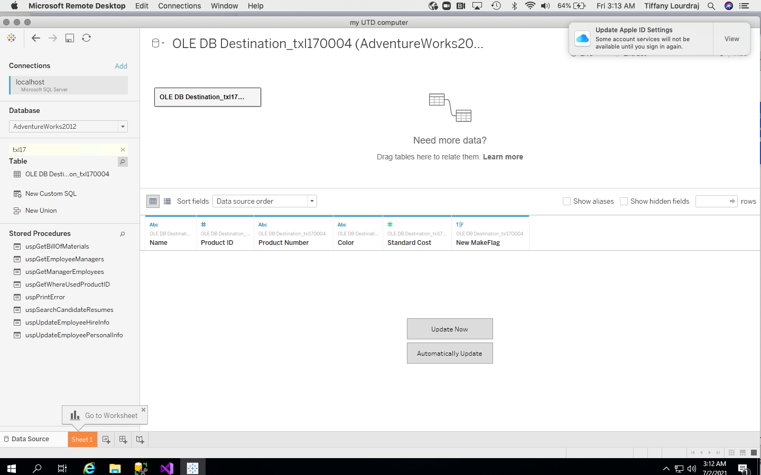

4. In an ideal situation, any new entry into the parent table should be extracted and displayed on Tableau. They want to test this by renaming any of the products at the source. A successful reflection of this change on Tableau will conclude the test. **Paste a screenshot of the SSMS Source Table with the change and Tableau screens. Also explain the whole process that triggered the change. Also talk about why the name of the product was changed at the source and not directly in the destination table. – 15 points It’s like 1:14 on 6/21**

To create the real time change in both applications, go back to the table destination and then the source which is production.product table. right click and select top 1000 rows. click on the cell of the data you want to change. Source data needs to be run through ETL and then will be shown on the Tableau. Run the ETL and change the destination to get it picked up by Tableau.

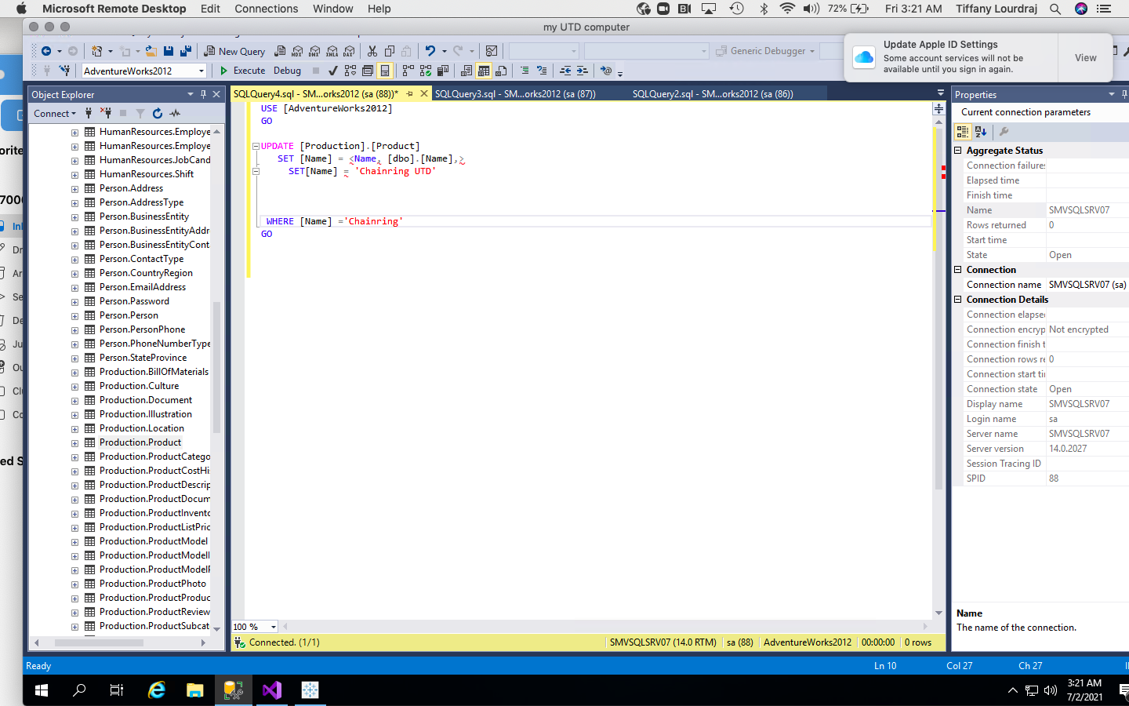

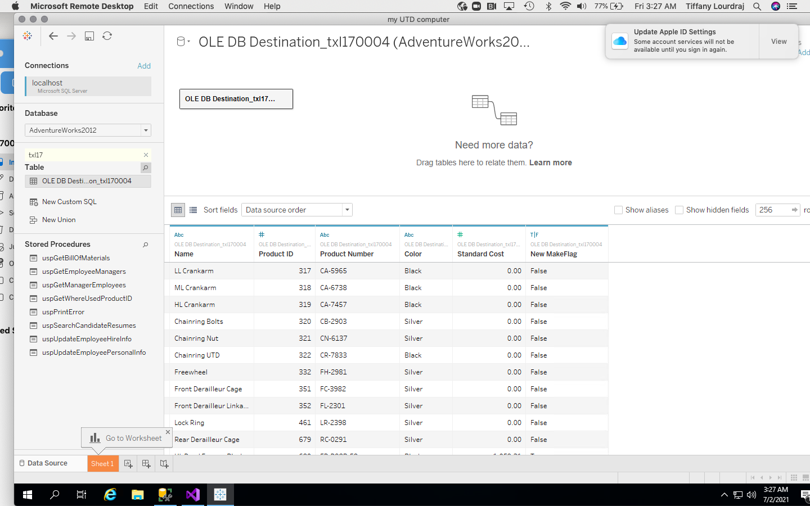

# Part 2: Cubes – 10 points

1. AdventureWorks Inc would like to build a cube from their source database AdventureWorks2012. They would like to extract the table – Product Vendor (Purchasing) and all the related tables. Using the Measure Groups of Product Vendor and Product, build a cube and browse it to list out the Product ID from the Product dimension, Unit Measure Code from the Unit Measure Dimension, Business Entity ID from Vendor dimension and the Standard Price listed under Product Vendor measure group. Add a Filter for all the Product IDs between 316 and 325 (Inclusive). **Paste a Screenshot below.**

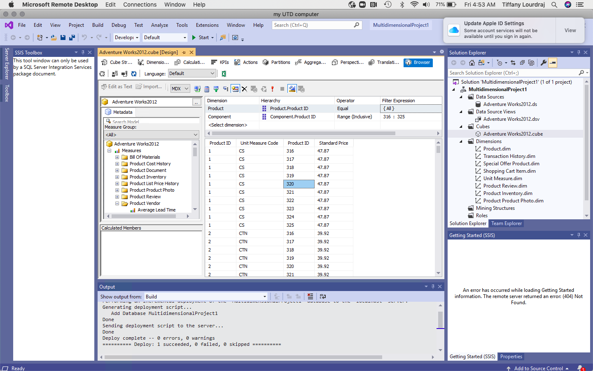

# Part 3: Tableau – 10 points

6/7- 2 hours mark

1. Use the dataset “Sample Superstore” listed under Saved Datasources in Tableau. Profit Ratio is an important parameter for the company. It simply means that if the Profits are equal to the sales, they have doubled their revenues. Which means that the max value of Profit Ratio can be “1”. Using this as a goal, use a Donut Chart to depict the percentage of profit ratio that is yet left to be achieved for the remainder of the year. Depict the numbers as percentages, upto 2 decimal places. Show this for all the categories, using one single sheet(line up each category next to each other). Remove the headers along the Y-axis.

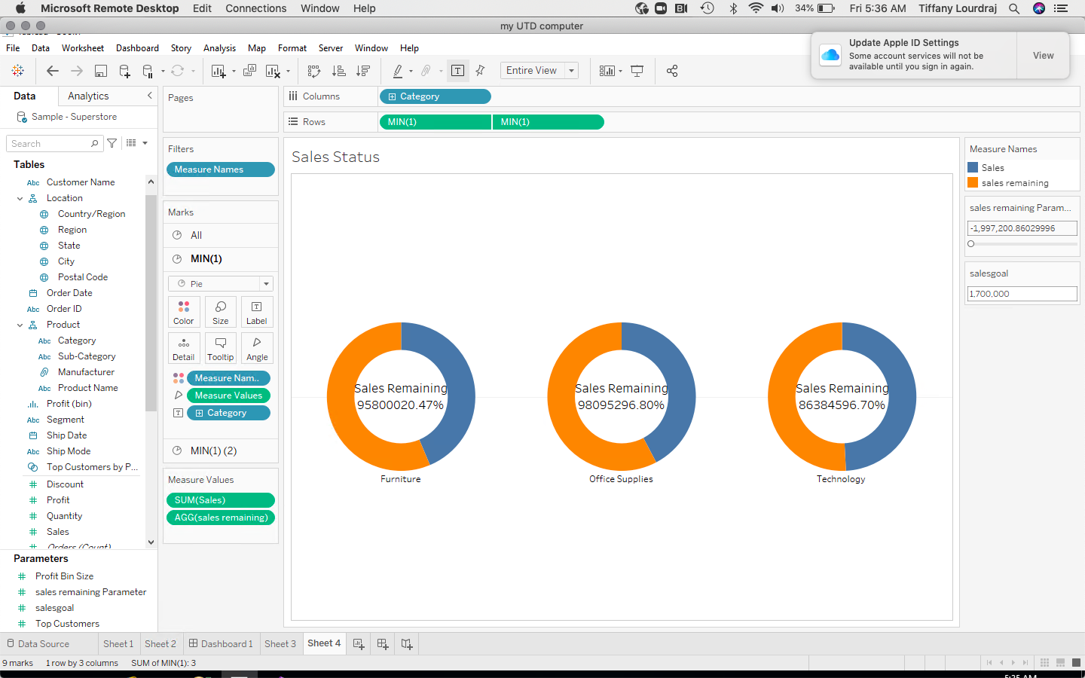

1. Create a Wordcloud to depict the Quantity sold for each of the Sub Categories. Color the Sub Categories based on their Profit, using the 5-stepped Blue Color palette.

